

**KIE 2003**

**Probability And Random Signal**

**Assignment**

**Name**  **:**  **Amos Lee Chiun Shian**  **(17207305)**

**Lee Yang Wei (17203987)**

**Ng Sau Ting (17205987)**

**Wee Gim Fung (17204859)**

**Problem Formulation**

Covid-19 first started to summit at the end of year 2019, which then begins to spread to the worldwide, becoming a novel pandemic disease. Throughout, the state of pandemic, myriad actions were taken in order to press down the spread of diseases. To verify and predict the spreading of Covid-19, mathematical modelling was introduced. Mathematical modeling can be viewed as a system that is defined using mathematical knowledge. The model helps to forecast the number of diseases in the future and allows the government to take action based on the prediction.

For this assignment, we are planning to create a model that allows us to predict the spreading pattern of Covid-19 over a certain time period influenced by different factors or parameters. In order for the model to come close to a real-world situation, we take into account various parameters or factors that affect the spreading pattern of Covid-19.

First, we look into the reproduction number, R0, which tells us how transmissible the Covid-19 is or in short, the average number of people a single infectious people can spread to. R0 can let us come up with three assumptions:

* R0 < 1, An infectious infects fewer than one person on average which indicates that in the long run, given a certain time, the disease will die out.
* R0 = 1, An infectious infects exactly one person on average, indicating the disease is now in stalemate whereby it is neither rising nor falling.
* R0 > 1, An infectious infects more than one person on average which indicates that the disease is highly transmissible, and the spreading will rise over time, leading to epidemic.

Based on the recent press by Ministry of Health, Malaysia, it is indicated that the R0 in the country of Malaysia centers around 1.2 which tells us that on average a single infectious can spread Covid-19 up to 1.2 person. The rate of transmissibility also can tell us a lot regarding the activities and measures practiced by Malaysian. Besides, we can compare the practice of using mask with without mask.

In the process of defining the rate of transmissibility, we assimilate the contact rate or in context, the average rate an infectious come into contact with another person neglecting the chance on getting infected. Contact rate can be defined over certain measures such as the practice of social distancing or physical distancing. With frequent practice on Movement Control Order (MCO), the contact rate relative to transmission rate will decline, indicating that the risk of getting exposed or infected by the infectious will reduce. The opposite will result in increase in rate of transmissibility.

Questions that normally swells up in the public, “how long does it takes to recover from Covid-19?” and “how likely will I get infected again upon recovery?”. Taking into consideration, we define the rate of recovery and the rate of lost of immunity. Without proper vaccination, one can never achieve total immunity against Covid-19. The parameter lost of immunity rate discusses the fact that the immunity level of different individuals might result in different results. We know that children and elderly tend to have a weaker immunity against diseases compare to teenagers and adult, thus, we can separate the population into two categories, those with weak immunity and those with strong immunity, resulting in the rate of loss of immunity. Bear in mind that, those whom loss the immunity has the same likelihood to be infected again.

Since we discussed on the fact that different individuals have different immunity against disease, the same context applies on the rate of recovery of the individual. By differentiating those with fast rate of recovery (in good health condition) and those with slow rate of recovery (in bad health – cancer patient, bedridden patient and etc), we can analyze on the effect of rate of recovery governing the covid-19 modelling.

Also, noticing the fact that those infected should not be wandering around in the public, the usage of quarantine is exposed to the public. When one is infected, they will be quarantined either self-isolation or hospitalized to prevent any further spread of disease. With that hospitalization rate is introduced to the forecast model. It allows us to predict on the effect of hospitalization throughout the pandemic period. High hospitalization rate indicates that those infected will be quickly quarantined in a closed space to ensure full recovery while preventing further spread of disease. By hypothesis, high hospitalization rate will reduce the amount of infection over time. Whereas low hospitalization rate will showcase the opposite.

Finally, when simulating a model, we will analyze on the effect of the population density of the population. In order to forecast the model with greater precision, we normally assume the size of population does not change over time. However, the population density effect on disease transmission is clear when we fix it at a certain enclosed area. When population density in an enclosed area increases, the transmission rate or contact rate will undoubtedly increase. Just like when comparing to the Brownian’s movement, when the number of particles increases, the rate of collision will increase. The above factor can be symbolized by the practice of social distancing.

By discovering and analyzing all the factors involved, we will then transfer the parameters into a simulation model. In our case, we will be making use of the SEIHRDS(Susceptible-Exposed-Infected-Hospitalised-Recovered-Death-Susceptible) model.

**Mathematical Modelling – Spreading Model**

While introducing this SEIHRDS model, there are a few assumptions to be made:

* We assumed that international travel had introduced transmission into the local setting but then played no further role in local transmissions, assuming a closed population. This was mitigated by travel restrictions.
* There is no new-born baby and natural death (except for those died of covid-19) during this period of estimation, so the population remains constant over time.
* Everyone in the population has equal probability of transmitting the disease, hence we assumed homogeneous mixing.
* There is asymptomatic transmission as well as symptomatic transmission.
* Antibody does not last long in human’s body so there will be rate of immunity lost, depending on age, healthiness and lifestyle of each person.
* SIR model here has been sub-divided into more compartments to provide a better representation on current scenario, they are the Exposed (E) and Hospitalized (H).

In the above mentioned SEIHRDS model, everyone in the population is susceptible initially except for initial population of infected category. Exposed compartment basically categorizes those who have been in close contact with infected persons and are now being infected. However, they are not aware that they are infectious, and they continue to move around while they under incubation period. Once symptoms of covid-19 show up, they will move into infected category. Here, the difference between infected and exposed is that those categorized under infected category have their symptoms shown up while those exposed ones do not have. The same thing happens here, they travel freely within the confined area and can transmit the disease to susceptible population since some people in reality, they did not realize symptoms of covid-19 are showing up and they thought it is the symptoms of other common diseases, so they did not go for SWAB test and continue to move around. Moving on to the next compartment which is the hospitalized category in which infected people are being traced and are asked to quarantine at hospital or quarantine centre to receive proper treatment. In this way, they can be considered as not infectious since they are out of reach of susceptible persons and they will move into recovered group once they recover from the disease. Therefore, this recovered population will consists of two groups of people, those who recovered themselves without being hospitalized and those who have successfully developed immunity against covid-19 during hospitalization. The recovery rate will depend on the condition, if they are hospitalized then their recovery rate will be higher as proper treatment from hospital is better than own body immunity, so those who are in infected category will have lower recovery rate. Anyhow, our simulation will not go into a state where everyone will have immunity against covid-19 and this pandemic will finally end as we assume there is immunity lost so there is possibility where people from recovered population will once again enter the susceptible category as the antibody does not last for eternity. Frankly saying, even vaccine being produced currently does not guarantee a 100% recovery rate (a few percent that it does not provide full immunity) and the period of immunity is still an unknown, meaning that we do not know how long it would last, how long do we need to get injection again to activate the immunity system again. Therefore, it is reasonable for us to assume immunity lost in this model and those who have lost their immunity will move from the recovered category back to susceptible again. The last compartment will be the dead category. This category receives people who were defeated by covid-19 regardless of whether they are hospitalized or not and we assume that this virus will not kill any living human before the symptoms show up so some of the infected people and quarantined people will move here after they passed away. The general parameters and formulas are as follow:

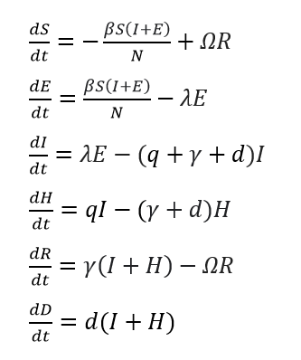 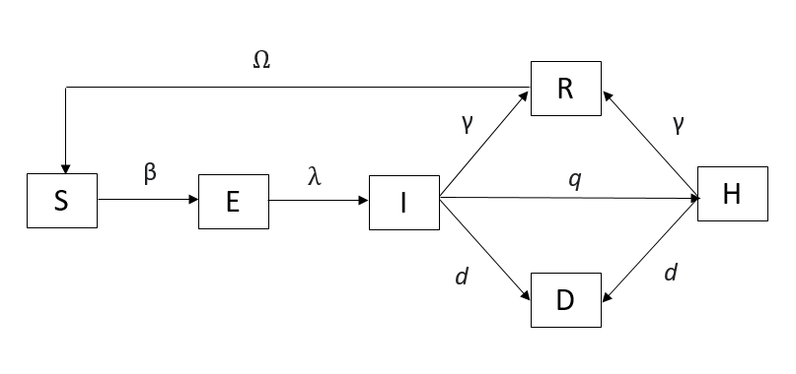

*Figure 1: Formulas (left) and visualisation (right) of our modified SEIR model*

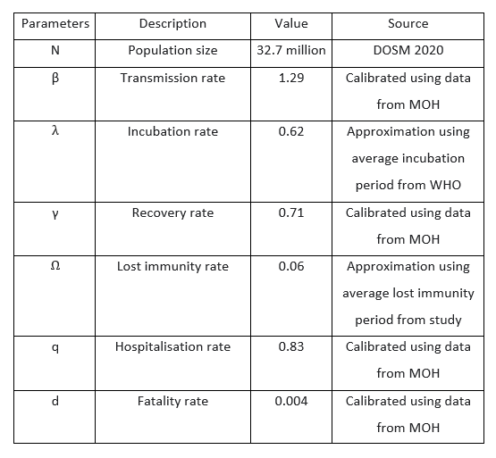

*Table 1: Description of the parameters and their corresponding values used in model simulation with sources provided*

**Stochastic process (Discrete Time Markov Chain)**

Here, in this assignment, we opted to model the spreading pattern of covid-19 using Discrete Time Markov Chain (DTMC), which is a stochastic process because the spread of disease is usually prone to randomness. The decision to apply DTMC in modelling covid-19 is because in most diseases, the present outcome may affect the future outcome and the transitions from one state to any other state depends on the current state and time. If that is the case, we only need information about current state for us to be able to predict the future state and that is why Markov Chain is used. Similar case as covid-19 here, since we are recording the cumulative number of different populations at each day, for example, only those who are infected at day 3 can move around and infect the others, influencing the number of infected on day 4. This is the so-called Markov property as we do not need to know about the number of infectives on day 1 or 2 (past states) but only need to know the number of infectives on day 3 (present state) that enables us to predict the future number of infectives on day 4. In this case, it is discrete time because we are dealing with countable sets of time.

Some important factors in using Markov property to define the probabilities of transition from one state to another state in every compartment are as follow:

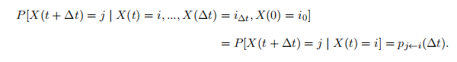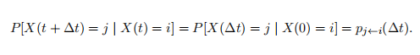

The process at any time t + ∆t depends only on the state of the immediate past process in time t and we assume that the process is time homogeneous, that is, the transition probability does not change with time. The formulas shown above are about one state transition which is the same as what we applied.

To begin modelling the disease, we first assume that the population is constant, and all the parameters extracted are based on real time parameters as shown in table 1. Markov process is precise if the time step between the transition sate is small enough that introduce more uncertainty into our models which are desired. In our case, the time step chosen between the transition state is 0.0001 so that we may assume at most one transition happens during each small-time step. For each time step, only one of the following can occur:

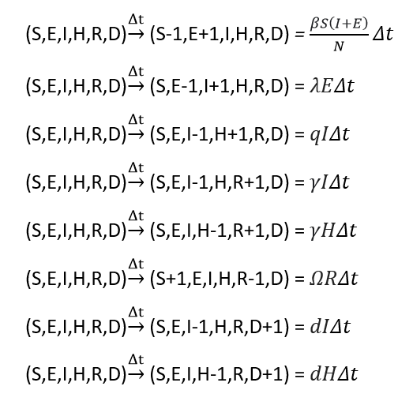Every change in time, it is only possible that one people will get infected and move to exposed, or exposed people have symptoms show up and move to infected, or infected people are hospitalised, or infected people recovered without getting treatment, or hospitalised people recover from the disease, or recovered people lost their immunity and move back to susceptible, or infected people die, or hospitalised people die, or nothing happens.

The formula for calculating probability of every possible transitions is summarised as below:

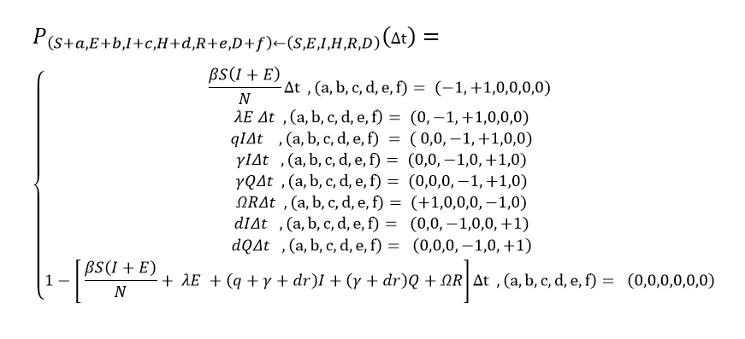

To determine whether at each time step, which of the 9 cases listed above will happen, we will generate a random number in between 0 to 1. After that, we will compare the random probability generated with the range specified for each of the 9 cases above. If the random probability generated is within the range of particular case, then that case will happen. A clearer view on the overall flow of this sections will be shown below, but only part of the algorithm code since the space is limited.

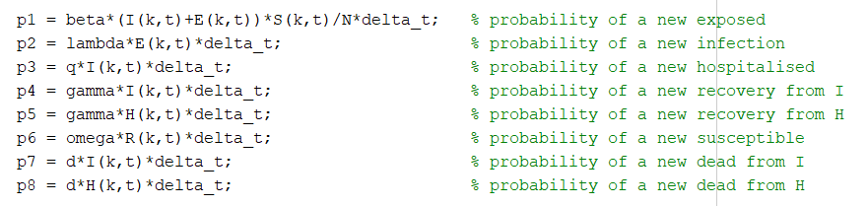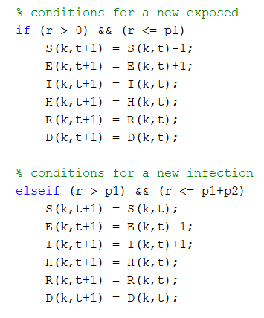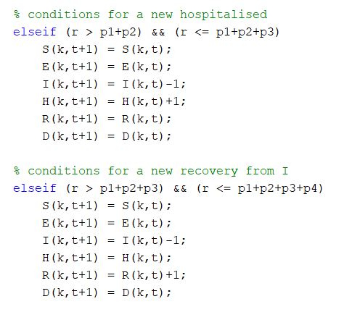

The above algorithms hold true as for example if the number of exposed becomes higher, the probability of transition from susceptible to exposed tends to be higher as well as they are directly proportional. Hence, the probability that the random generated probability will fall within this range will increase and there will be more likely to have increased exposed population and so on. It still retains its randomness as we are not saying that for a probability of 80% ,4 out of 5 people will be the exposed but rather it is about for every person, they have probability of 80% to become exposed.

In fact, if we further reduce the delta time to be smaller than 0.0001, the result will be more accurate as we are now assuming 1000 transitions per day only, but there might be more. Generally, Markov Chain in this model has provided an accurate result for us to predict the spreading pattern of covid-19 in the near future because we basically randomize the smallest element we could – each transition, and then the latest data is being fed back to the loop to calculate the probability of next state, therefore it is closer to an ideal stochastic process as compared to predicting the data day by day by using average value of the collected data because the outcome will not deviate much from the average number.

**Model Simulation**

Below will be the results and discussions for what we have explained in the problem formulation.

The first factor that we considered is the age of citizens. As we know that, elderly and children are expected to have a lower rate of recovery as well as higher rate of loss of immunity. Hence, when we are simulating the virus simulating pattern within an area with higher proportion of elderly, the rate of recovery, gamma is reduced. The rate of loss of immunity, omega, is increased.

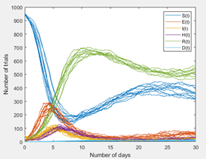 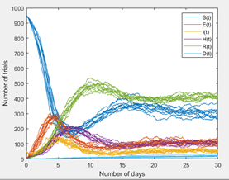

The first graph simulates the spreading pattern of real-time value of parameters. The second graph simulates the spreading pattern of elderlies where recovery rate is decreased to 0.4 and lost immunity rate is increased to 0.1. We have noticed that in the second graph, the number of people remained in recovered category have reduced. This is due to the higher rate of loss of immunity among elderlies, which leads to more transitions from recovered category to susceptible category. If they are infected with the virus, they are less likely to recover due to natural health condition. This also indirectly increases the total amount of deaths and amount of hospitalization cases throughout the 30-days simulation. It is expected that the elderlies will stay in exposed, infected and hospitalized categories without recovering from the disease for a longer period, and thus leading to more death cases.

The second factor is population density. Urban areas and rural areas have different density of population. Assuming same population, the former is denser while the latter is less dense. Hence, people in urban areas are more likely to encounter each other due to limited area of activity thus having higher transmission rate. In contrast, people in rural areas have lower transmission rate, as they have larger area of activity and do not come in contact easily with each other. Given that the spreading pattern simulated with normal parameters are used to reflect the situation in urban areas, the spreading pattern of the disease in rural areas will be visualised by decreasing the transmission rate between the susceptible and infectious individuals.

 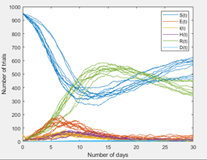

The first graph simulates the spreading pattern of real-time value of parameters in urban areas. The second graph simulates the spreading pattern in rural areas with amended value of parameters, where transmission rate is decreased to 1. As we observe, people in the rural areas are less likely to be infected. This reflects the real-life situation, where in Malaysia, most of the outbreak occurs in urban area as they are more densely populated. The level of social activities in urban areas are high compared to in rural areas. Hence, they are not able to fully practice social distancing from time to time, causing the transmission rate to be very high and the number of cases surged in only few days.

The third factor that we want to analyse is the hospitalisation rate. Every country has only limited slots in hospital and once it is fully occupied, the medical system can no longer support the outbreak, like what happened in the US. Hence, to study how hospitalisation rate would affect the spreading pattern, we would change the hospitalisation rate and compare the two graphs.

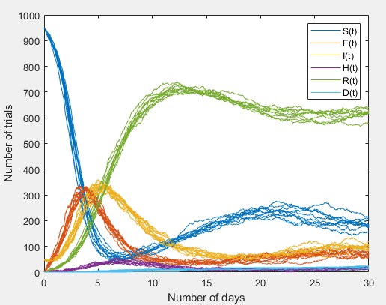

The first graph simulates the spreading pattern of real-time value of parameters. The second graph simulates the spreading pattern with amended value of parameters, where hospitalisation rate = 0. We can observe that in the second graph, the number of people in exposed and infected categories rise higher within the first five days. This shows that hospitalising the patients are effective in controlling the infected cases, as patients are isolated. In real life, it is crucial to maintain the high hospitalisation rate among the infected as a measure to prevent the disease from further spreading.

**REFERENCE**

* IDM. SEIR and SEIRS models. Retrieved from <https://docs.idmod.org/projects/emod-hiv/en/latest/model-seir.html>
* Tchvadar T, Rossitza S..(2020). Dynamics of COVID-19 using inverse problem for coefficient identification in SIR epidemic models. DOI : <https://doi.org/10.1016/j.csfx.2020.100041>
* NewStraitsTimes. Dr Noor Hisham: Malaysia's Covid-19 infectivity rate is now 1.2. Retrieved from <https://www.nst.com.my/news/nation/2020/10/635813/dr-noor-hisham-malaysias-covid-19-infectivity-rate-now-12>
* Statista. Face Masks & Physical Distancing Reduce COVID-19 Risk. Retrieved from <https://www.statista.com/chart/21882/chance-of-covid-19-transmission/>
* Hamidi, S., Sabouri, S., & Ewing, R. (2020). Does density aggravate the COVID-19 pandemic? Early findings and lessons for planners. *Journal of the American Planning Association*, *86*(4), 495-509.
* Klein, S. L., Pekosz, A., Park, H. S., Ursin, R. L., Shapiro, J. R., Benner, S. E., ... & Tobian, A. A. (2020). Sex, age, and hospitalization drive antibody responses in a COVID-19 convalescent plasma donor population. *The Journal of clinical investigation*, *130*(11), 6141-6150.
* World Health Organization. Coronavirus disease (COVID-19): Herd immunity, lockdowns and COVID-19. Retrieved from <https://www.who.int/news-room/q-a-detail/herd-immunity-lockdowns-and-covid-19#:~:text=Research%20is%20still%20ongoing%20into,develop%20an%20immune%20response>.
* Kementerian Kesihatan Malaysia. Situasi Semasa Pandemik COVID-19 Di Malaysia. Retrieved from <http://covid-19.moh.gov.my/>
* The Guardian. Immunity to Covid-19 could be lost in months, UK study suggests. Retrieved from <https://www.theguardian.com/world/2020/jul/12/immunity-to-covid-19-could-be-lost-in-months-uk-study-suggests>
* nature. What is the immune response to the coronavirus says about the prospects for a vaccine. Retrieved from <https://www.nature.com/articles/d41586-020-02400-7>
* BBC News. Covid: Antibodies ‘fall rapidly after infection’. Retrieved from <https://www.bbc.com/news/health-54696873>
* EdgeProp. No report of long Covid-19 incubation period in Malaysia, says Noor Hisham. Retrieved from <https://www.edgeprop.my/content/1756914/no-report-long-covid-19-incubation-period-malaysia-says-noor-hisham>
* World Heath Organization. Transmission of SARS-CoV-2: implications for infection prevention precautions. Retrieved from [https://www.who.int/news-room/commentaries/detail/transmission-of-sars-cov-2-implications-for-infection-preventionprecautions#:~:text=The%20incubation%20period%20of%20COVID,to%20a%20confirmed%20case](https://www.who.int/news-room/commentaries/detail/transmission-of-sars-cov-2-implications-for-infection-prevention-precautions#:~:text=The%20incubation%20period%20of%20COVID,to%20a%20confirmed%20case).